# CS 255 System Design Document Template

Jonathan Boeglin

## UML Diagrams

### UML Use Case Diagram

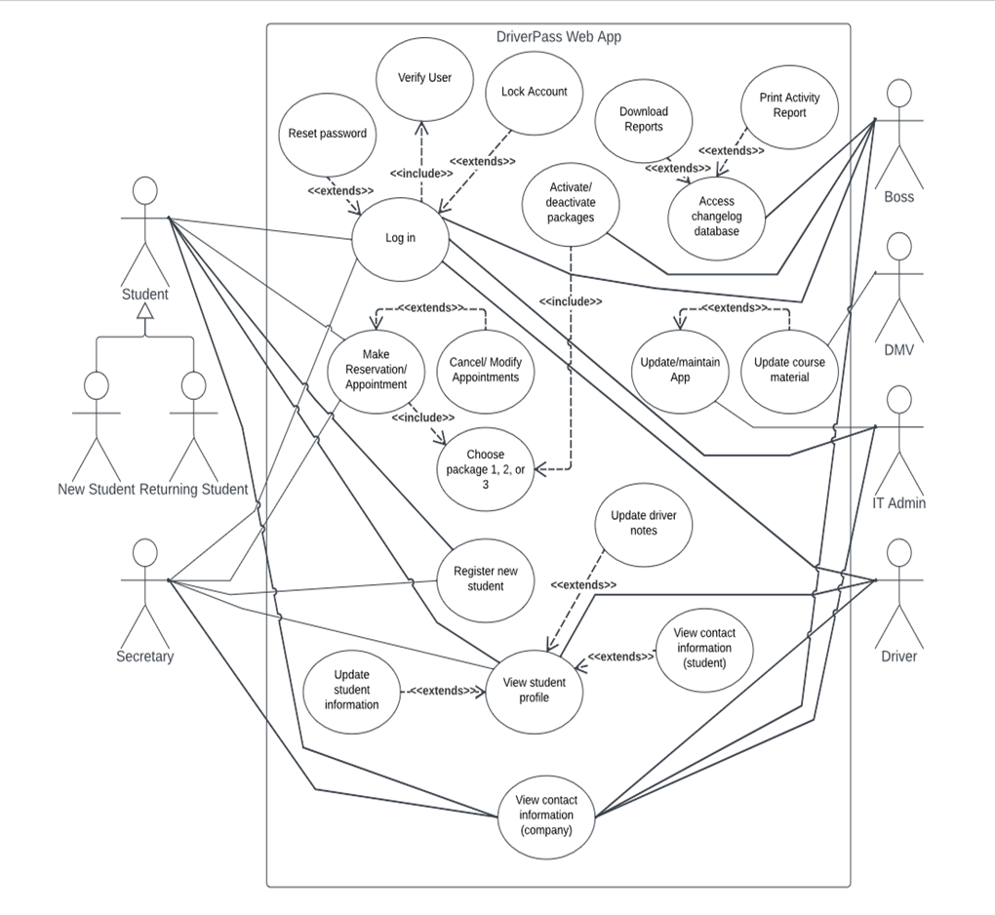

### UML Activity Diagrams

User login and Student profile access/modification use cases:

### UML Sequence Diagram

Use case: User logging into system

### UML Class Diagram

## Technical Requirements

Hardware:

* Hosts for system
* Computers/mobile phones for access

Software:

* Cloud-based architecture to run system
* System itself
* Modern, updated web browser
* OS that runs on computer or mobile device to access browser
* C++ coding
* Security for system

Infrastructure:

* Sufficient storage for data needed by system
* Sufficient RAM for browser access
* Security for protecting system hosts
* Consistent wired connection to internet for system